Parallel Programming

Program #3 Arrays and Matrices

Solve this scientist’s problem using matrices and R.

A nature researcher is monitoring the health of African Apes called the Apeasouraus Species. The data collected so far shows that there are 100 male children, 80 male adults, 120 female children, and 100 female adults.

They are currently monitoring a situation where a strange virus has infected the group. The virus called the Bacteriophage virus causes fatigue, vomiting, and weight loss among these precious creatures so they want a way to compare how many are healthy versus how many are sick. Currently, approximately 15% of the male and female children and 25% of the male and female adults are healthy. Approximately 35% of the male and female children and 30% of the male and female adults are sick. It is also important to note that 50% of the male and female children and 45% of the male and female adults are carriers of the Bacteriophage virus.

Using matrix operations and R develop a script the will find out, for the scientist, how many males and how many females (don’t need to divide by class) are healthy, sick, and carriers.

From the above data you should get:

Healthy males = 35

Healthy females = 43

Sick males = 59

Sick females = 72

Carrier males = 86

Carrier females = 105

Once you get these values – plot them like this:

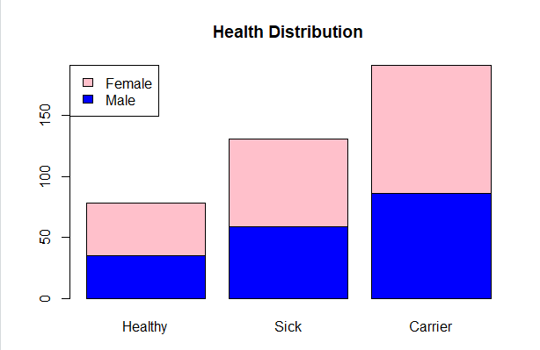

Submit the text of your code, along with screen shots of it working on your system for grading.